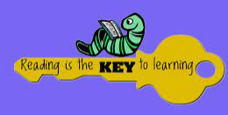
- READ A TEXT ABOUT A CURRENT AFFAIRS MATTER. WRITE A SHORT SUMMARY OF WHAT YOU HAVE READ. | - READ AND REMEMBER THIS ARTICLE (CAN YOU TELL OTHER PEOPLE ABOUT IT)?  ARTICLE 22 (REFUGEE CHILDREN) IF A CHILD IS SEEKING REFUGE OR HAS REFUGEE STATUS, GOVERNMENTS MUST PROVIDE THEM WITH APPROPRIATE PROTECTION AND ASSISTANCE TO HELP THEM. | 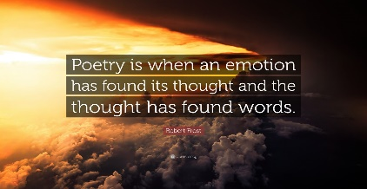  - READ A POEM AND TRY TO WRITE ONE IN THE SAME STYLE. | 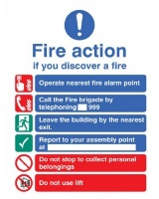  - READ SOMETHING THAT IS NOT A BOOK AND WRITE DOWN WHY YOU CHOOSE THIS.
- READ A BOOK BASED ON A TRUE STORY. WRITE DOWN WHAT THE TRUE STORY IS ABOUT. | - SWAP A ABOOK WITH A FRIEND. ASK THEM WHAT THEY LIKED ABOUT THE STORY AND WRITE IT DOWN. | - READ YOUR FAVOURITE BOOK AND WRITE DOWN WHY ITS YOUR FAVOURITE, | - READ AN EBOOK. WRITE DOWN WHAT THE BOOK WAS AND WHERE YOU READ IT (iPad, computer, tablet)
- READ A BOOK ABOUT RESPONSIBILTY AND ANSWER QUESTIONS ABOUT IT. | - READ A BOOK ABOUT DEMOCRACY AND ANSWER QUESTIONS ABOUT IT. | - READ A BOOK ABOUT EDUCATION AND ANSWER QUESTIONS ABOUT IT. | - READ A BOOK ABOUT ASPIRATIONS AND ANSWER QUESTIONS ABOUT IT.
- READ A KEY TEXT AND DISCUSS WITH YOUR TEACHER OR AN ADULT AT SCHOOL. | - READ A BOOK YOUR TEACHER OR AN ADULT IN SCHOOL HAS RECOMMENDED AND ANSWER QUESTIONS ABOUT THE STORY. | - READ A NON-FICTION BOOK AND DISCUSS WITH YOUR TEACHER OR AN ADULT AT SCHOOL. | - READ A TRADITIONAL TALE AND DISCUSS WITH YOUR TEACHER OR AN ADULT AT SCHOOL.
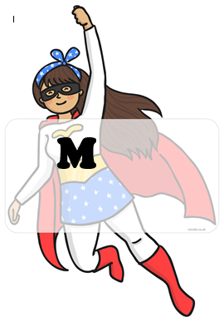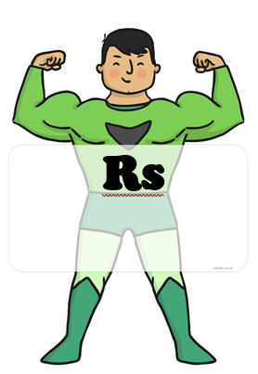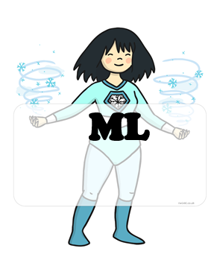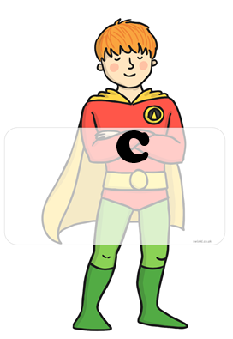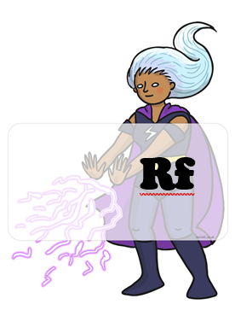 BLUE : home challenges YELLOW : school challenges

