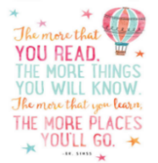
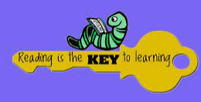
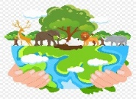  - READ A BOOK OR AN ONLINE ARTICLE ABOUT THE ENVIROMENT OR SAVING THE PLANET. WRITE ABOUT WHAT YOU CAN DO TO HELP OUR PLANET.  Completed: | - RE-WRITE THE BLURB FOR A BOOK YOU HAVE ENJOYED.  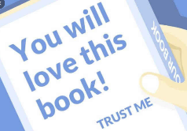  Completed: | 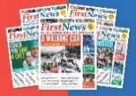  - READ A NEWS ARTICLE FROM A NEWSPAPER, MAGAZINE, ONLINE OR A TABLET AND WRITE A SUMMARY OF THE ARTICLE.  Completed: | - READ AND REMEMBER THIS ARTICLE (CAN YOU TELL OTHER PEOPLE ABOUT IT?)  ARTICLE 29. YOU HAVE THE RIGHT TO EDUCATION WHICH TRIES TO DEVELOP YOUR PERSONALITY AND ABILITIES AS MUCH AS POSSIBLE AND ENCOURAGES YOU TO REPSECT OTHER PEOPLE’S RIGHTS AND VALUES AND TO REPSECT THE ENVIROMENT.  Completed:
- READ SOMETHING LINKED TO YOUR FAMILY, YOUR CULTURE OR YOUR HERITAGE AND WRITE DOWN WHAT YOU FOUND OUT.  Completed: | - READ AN AGE APPROPRITE BOOK PUBLISHED IN THE LAST YEAR AND WRITE DOWN YOUR THOUGHTS ON THE BOOK.  Completed: | - READ A CLASSIC BOOK AND WRITE A REVIEW  Completed: | - THINK OF A STORY YOU COULD WRITE AT HOME AND WRITE DOWN WHAT THE STORY IS ABOUT AND ONE OF THE CHARCATERS.  Completed:
- READ A BOOK ABOUT DIVERSITY AND ANSWER QUESTIONS ABOUT IT.  Completed: | - READ A BOOK ABOUT IDENTITY AND ANSWER QUESTIONS ABOUT IT.  Completed: | - READ A BOOK ABOUT COMMUNITY AND ANSWER QUESTIONS ABOUT IT.  Completed: | - READ AND COMPARE 2 BOOKS BY THE SAME AUTHOR, TELL AN ADULT ABOUT THE DIFFERENCES.  Completed:
- READ AN ATLAS OR BOOK ABOUT THE WORLD AND ANSWER QUESTIONS ABOUT IT.  Completed: | - READ ONE OF AESOP’S FABLES AND TELL AN ADULT WHAT THE LESSON WAS.  Completed: | - READ A BOOK THAT IS PART OF A SERIES AND DISCUSS HOW THE BOOK FITS IN TO THE WHOLE STORY.  Completed: | - READ A STORY FROM ANOTHER CULTURE AND ANSWER QUESTIONS ABOUT IT.  Completed:
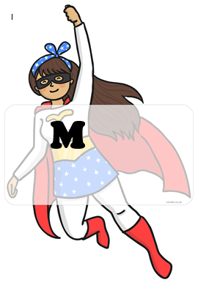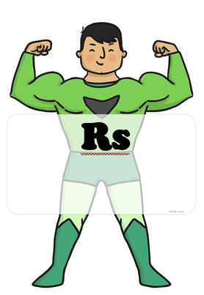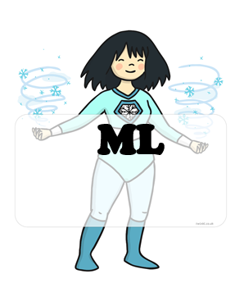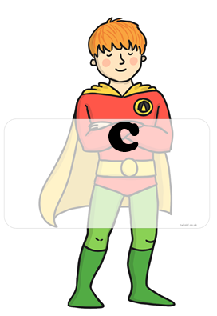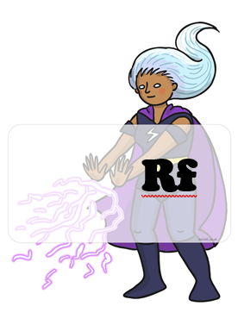 BLUE : home challenges YELLOW : school challenges

HOME CHALLENGES EVIDENCE
CHALLENGE 6:
CHALLENGE 5:
CHALLENGE 4:
CHALLENGE 3:
CHALLENGE 2:
CHALLENGE 1:
CHALLENGE 8:
CHALLENGE 7:

